**Eliminate Duplication By Composition**

*unrelated classes host duplicate code that presents a responsibility of its own*

*capture the missing responsibility with a class and factor out the duplication by means of composition*

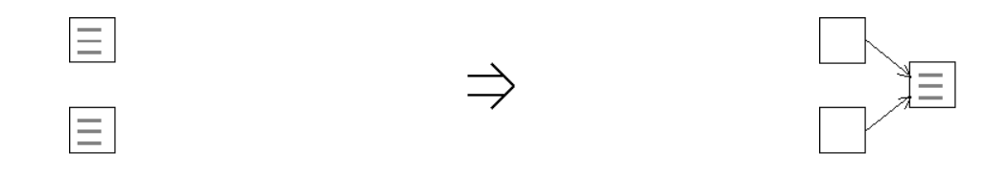

**Context:**

When a new abstraction has been recognized [Eliminate Duplication By Composition](https://web.archive.org/web/20090914084953/http:/www.refactoring.be/thumbnails/rtn-edbc.html) can be used to [Consolidate Abstraction](https://web.archive.org/web/20090914084953/http:/www.refactoring.be/thumbnails/rtn-ca.html) and prevent the similarities from diverging.

See also :[Eliminate Duplication By Inheritance](https://web.archive.org/web/20090914084953/http:/www.refactoring.be/thumbnails/rtn-edbi.html)